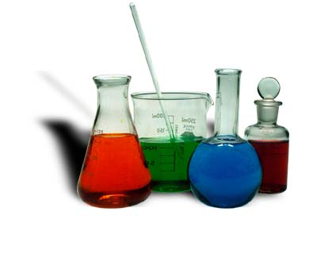
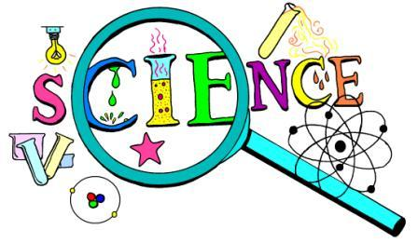
Narrogin Senior High School
Year Seven Science

CONTENT OVERVIEW:
- Laboratory safety
- Laboratory equipment
- Planning, conducting and evaluating experiment design

CONTENT DESCRIPTIONS:

Science Inquiry Skills

Questioning and predicting
- Identify questions and problems that can be investigated scientifically and make predictions based on scientific knowledge

Planning and conducting
- Collaboratively and individually plan and conduct a range of investigation types, including fieldwork and experiments, ensuring safety and ethical guidelines are followed

- In fair tests, measure and control variables, and select equipment to collect data with accuracy appropriate to the task

Processing and analysing data and information
- Construct and use a range of representations, including graphs, keys and models to represent and analyse patterns or relationships, including using digital technologies as appropriate

- Summarise data, from students’ own investigations and secondary sources, and use scientific understanding to identify relationships and draw conclusions

Evaluating
- Reflect on the method used to investigate a question or solve a problem, including evaluating the quality of the data collected, and identify improvements to the method

- Use scientific knowledge and findings from investigations to evaluate claims

Assessments
Task 1 Science Investigation Bouncing Balls
Task 2 Investigating Test
